

Technical Design

NBCU International – Theatrical Box Office
[This document intended to summarize the Technical design for Theatrical Box Office]

Contents
1.0 Overview 4
2.0 In-Scope 4
3.0 Technical Design 5
3.1 Objects Collection: 5
3.2 BW HANA Object Migration: 6
3.3 SLT Setup and HANA Development 6
3.3.1 SLT Setup 6
3.3.2 Data Flow 7
3.3.3 HANA Objects 25
3.3.4 Bex Queries 26
4.0 Assumptions & Dependencies 27
4.1 Assumptions 27
4.2 Dependencies 27
5.0 Reference Documents 27
6.0 Open Items 27

  - Version History
Version Number | Change Date | Changes Incorporated | Author | Approver
1.0 | 09/12/2019 | Initial Draft Version | Sai Krishna Narahari

  - Related Documents
Document Name | Predecessor /Successor | Link to the Document
Blue Print Document | Predecessor
 | Predecessor
 | Successor

1.0 Overview
NBC Universal is looking to migrate current BW system to HANA platform. This project will outline all existing solutions on the International SAP BW system that will require migration on to a new SAP BW on HANA platform.
As Part of the NBC Universal road map for SAP products, we are moving our solutions on to a new SAP HANA platform, this extends to the SAP BW systems so the UBP and BP1 systems will be migrating from a BW 7.3 system on an Oracle database to a BW 7.4 system on a HANA database.
Theatrical Box Office have the Release dates, TCR revisions, Pub1, Box Office(Midas) & Title Forecasting, Title, Territory & MPM Format OpCo view.
The Theatrical Box Office BW flow is getting data from flat files and Power center,
- Master Data from Flat files and Power center
- Transaction data from Flat Files & Power center. Flat File data loads are not in Scope.

Objective of this project:
- Avoid redundant Storage of data in SAP BW eg: Data in Transformation Layer
- Easy enhancements in future
- Use HANA composite providers for Reporting

2.0 In-Scope
Below flows of Theatrical Box Office solutions are in Scope for this project,
- UPIX Master data (As-IS no modification required and available in the production environment)
  - Z_UPI0603 - MPM Format OpCo View (UPI)
  - Z_UPI0626 - Territory (Midas)
  - Z_UPI0632 - Title (Midas)
- TCR Revisions.
- TCR Print Cost Estimates (Using for only History data. we will get history data using DataMart from Int BW system)
- Box Office Daily.
- Box Office Cumulative (Using for only History data. we will get history data using DataMart from Int BW system)
- Release dates (DSO’s already available till production. Created ADSO’s in place of old DSO’s, This data will feed into MD)
- Commitments Cube – Corresponding Calculation View already available in Production - CV_INT_MRKT_CMPGN_COMMITMENT
- Z5 Ledger Totals UPI – created on top of ZFEMP06 - CV_INT_TBO_ZFSL

3.0 Technical Design
Proposed high-level design approach.
Objects Transport and Migration
BW HANA Object Conversion
HANA Development
Integrate Reporting Tools to HANA
- Objects Collection and Validation
- Transport of objects to BW on 7.4 HANA
- Migrate 3.x flows to 7.x

- server
- Validation of Transported objects
- Conversion of Standard and Write Optimized DSO’s to Advanced DSO’s

- Development of HANA Calculation views on top of ADSO’s implementing transformation logic in BW
- Integrate Report to Hana composite providers

3.1 Objects Collection:
Attached list of objects will be collected from BQ4 system and transport to HBD Development system.

List of objects to be migrated from HBD to H2D
None

3.2 BW HANA Object Migration:
Once above listed objects are collected and migrated in BW 7.4 on HANA, then using SAP standard program all current Standard or
Write – Optimized DSO is converted to Advanced DSO’s.
SAP Program: RSO_CONVERT_IPRO_TO_HCPR

3.3 SLT Setup and HANA Development

3.3.1 SLT Setup
SLT will be setup for below identified tables: None
 | SAP Table | Description | HANA Package | Calculation View | Existing View

3.3.2 Data Flow
Master Data :
Below master data objects,
MPM Format OpCo View (UPI) | Z_UPI0603
Territory (Midas) | Z_UPI0626
Title (Midas) | Z_UPI0632

MPM Format OpCo View Info Objects: Z_UPI0603
0CHANGEDBY | Changed by
Z_UPI0100 | MPM Title
Z_UPI0101 | MPM Format
Z_UPI0304 | BW Change Date
Z_UPI0474 | SYSG
Z_UPI0477 | UI Int Film
Z_UPI0606 | Title Status
Z_UPI0607 | Midas Release Date
Z_UPI0610 | Release Date / Status
Z_UPI0611 | Media Date TV
Z_UPI0612 | Media Date Outdoor
Z_UPI0613 | Media Date Internet
Z_UPI0614 | Media Date other
Z_UPI0620 | Slate Year
Z_UPI0621 | Pub 1
Z_UPI0629 | Release Status (Midas)
Z_UPI0692 | Midas Release Date (KF)
Z_UPI0700 | Parent MPM Title
Z_UPI0701 | Text

Territory (Midas) - Z_UPI0626
0COMP_CODE | Company code
0COUNTRY | Country key
0CURRENCY | Currency key
Z_UPI0010 | OpCo
Z_UPI0619 | Active for Master data creation
Z_UPI0634 | Heavy Currency Indicator (Midas)

Title (Midas) - Z_UPI0632
0CHANGEDBY | Changed by
Z_UPI0001 | FAME No
Z_UPI0100 | MPM Title
Z_UPI0101 | MPM Format
Z_UPI0304 | BW Change Date
Z_UPI0474 | SYSG
Z_UPI0477 | UI Int Film
Z_UPI0618 | inactive for duplication
Z_UPI0711 | US Release Date

Transaction Data:
1 As is: TCR – ZXTCR
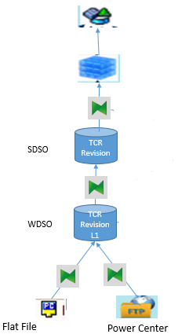

1 To-be:

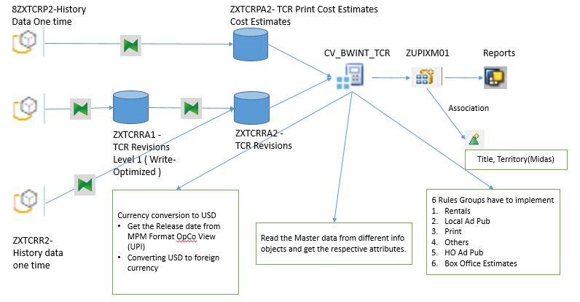

- TCR revisions data is loading via data source and source system will be Informatica.
- For Heavy Currency Conversion logic has written in Start routine and End routine.
- Convert Multi provider ZUPIXM01 to Composite Provider ZUPIXM01
- Convert Write Optimized DSO ZXTCRR1 to Advanced DSO ZXTCRRA1.
- Convert Standard DSO ZXTCRR2 to Advanced DSO ZXTCRRA2.
- The logics, calculations and time characteristics between DSO ZXTCRR2 to CUBE ZXTCR are built in Calculation Views,
  - CV_INT_TBO_TCR_RG
  - CV_INT_TBO_TCR_REVISION
  - CV_INT_TBO_TCR_COST_RG
  - CV_INT_TBO_TCR_PCE
  - CV_INT_TBO_TCR (Main CV)

- Created Composite provider ZUPIXM01 on top of this calculation view to generate the queries.

Filed Mappings from ZXTCRR1A to ZXTCR
Direct Mappings: 1-1 Mapping
Description | Source Field | Target Field
Territory (Midas) | Z_UPI0626 | Z_UPI0626
Studio ID | Z_UPI0631 | Z_UPI0631
Title (Midas) | Z_UPI0632 | Z_UPI0632
Data Type | Z_UPI0640 | Z_UPI0640
Revision | Z_UPI0641 | Z_UPI0641
Status (TCR) | Z_UPI0642 | Z_UPI0642
Planned Release Date(UpperCase) | Z_UPI0643 | Z_UPI0643
Revision Status | Z_UPI0644 | Z_UPI0644
Screened / Unscreen | Z_UPI0647 | Z_UPI0647
Amount in Local Curr | Z_UPI0662 | Z_UPI0026
Amount in OpCo Curr | Z_UPI0662 | Z_UPI0028
Format OpCo View UPI | Z_UPI0603 | Z_UPI0603
OpCo | Z_UPI0010 | Z_UPI0010

Read Table: Territory (Midas) - /BIC/PZ_UPI0626 | Source Filed | Target Field
Company code | 0COMP_CODE | 0COMP_CODE
Country | 0COUNTRY | 0COUNTRY

Read Table: Studio & Title(Midas) - /BIC/PZ_UPI0631 & /BIC/PZ_UPI0633 | Source Field | Target Field
MPM Title | Z_UPI0631 & Z_UPI0632 | Z_UPI0100

Field Level Routine: USD via Release Date
Description | Source Fields | Target Field
Amount in Group Curr | 0CURKEY_LC  Z_UPI0010  Z_UPI0603  Z_UPI0662 | Z_UPI0027  0CURKEY_GC

USD Currency conversion is based on the Amount in local currency(Z_UPI0026), local currency, release date.
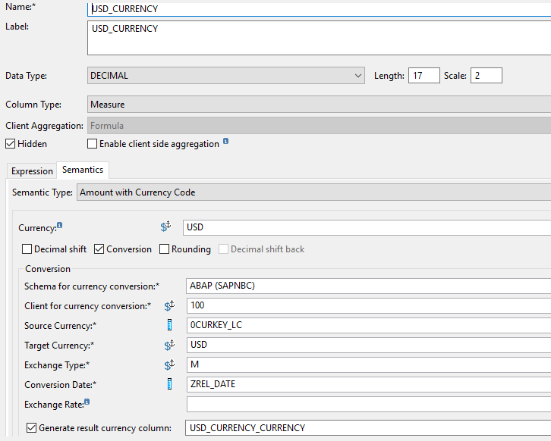

Created with existing key figure by including USD currency as shown below,
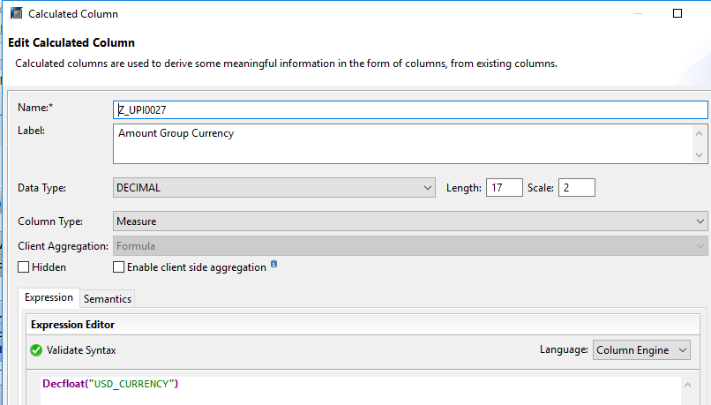

Rule Groups: Rentals, Local Ad Pub, Print, Others, HO Ad Pub, Box Office Estimate, Freight, Duty, Censor, Dubbing, Sub_Titling, Misc, Trailers
Z_UPI0204 | Account

Created a calculation view (CV_INT_TBO_TCR_RG & CV_INT_TBO_TCR_COST_RG) with the rule groups and assign it to Z_UPI0204 field.

2. Box Office Cube (Midas) - ZXBOX22
As-IS:

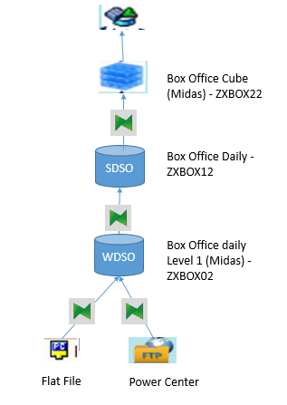

To-Be:
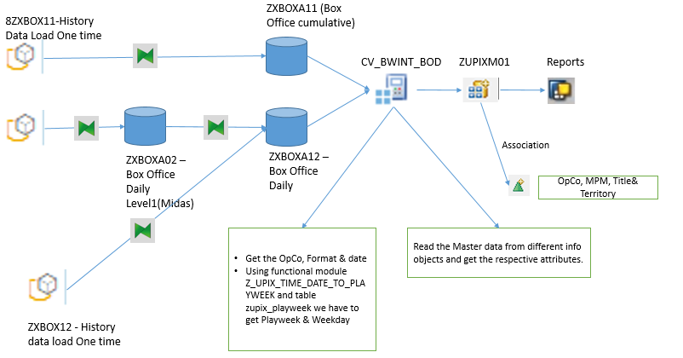
- Box Office Daily data is loading via data source and source system will be Informatica.
- For Heavy Currency Conversion logic has written in Start routine and End routine.
- Convert Multi provider ZUPIXM01 to Composite Provider ZUPIXM01
- Convert Write Optimized DSO ZXBOX02 to Advanced DSO ZXBOXA02.
- Convert Standard DSO ZXBOX12 to Advanced DSO ZXBOXA12.
- The logics, calculations and time characteristics between ZXBOX12 to ZXBOX22 are built in Calculation Views,
  - CV_INT_TBO_BOX_DAILY
  - CV_INT_TBO_BOX_CUMULATIVE
  - CV_INT_TBO_BOX_POST
  - CV_BWINT_TBO_BOX_OFFICE (Main CV)
- Created Composite provider ZUPIXM01 on top of this calculation view to generate the queries.

Field Mappings for the below fields used from _SYS_BI schema M_TIME_DIMENSION & M_FISCAL_CALENDAR
 | Source Field | Target Field
Calendar Year/Month | 0CALDAY | 0CALMONTH
Calendar day | 0CALDAY | 0CALDAY
Calendar year/Week | 0CALDAY | 0CALWEEK
Calendar year | 0CALDAY | 0CALYEAR
Fiscal year | 0CALDAY | 0FISCYEAR
Fiscal year / period | 0CALDAY | 0FISCPER
Fiscal year variant | K4 | 0FISCVARNT
Posting period | 0CALDAY | 0FISCPER3

Direct Mapping:
 | Source Field | Target Field
OpCo | Z_UPI0010 | Z_UPI0010
Amount in Local Curr | Z_UPI0026 | Z_UPI0026
Amount in Group Curr | Z_UPI0027 | Z_UPI0027
MPM Format OpCo View UPI | Z_UPI0603 | Z_UPI0603
Territory (Midas) | Z_UPI0626 | Z_UPI0626
Studio ID | Z_UPI0631 | Z_UPI0631
Title (Midas) | Z_UPI0632 | Z_UPI0632
Box Office Rec. Type | Z_UPI0633 | Z_UPI0633 ( Constant value DAILY)
Admissions | Z_UPI0654 | Z_UPI0654
OpCo | Z_UPI0010 | Z_UPI0010
Screens | Z_UPI0655 | Z_UPI0655

Playweek = Using Functional module “Z_UPIX_TIME_DATE_TO_PLAYWEEK” to get the Playweek .

 | Source Field | Target Field
Play Week | 0CALDAY & Z_UPI0010 & Z_UPI0603 | Z_UPI0601

Calculated the difference between calendar day and release date. If the difference is greater than start day and less than end day based on the backend table Z_UPIX_PLAYWEEK it will populate the play week value.
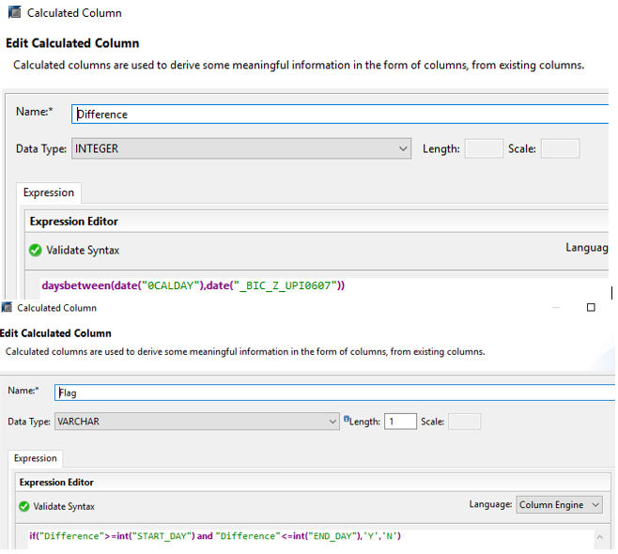

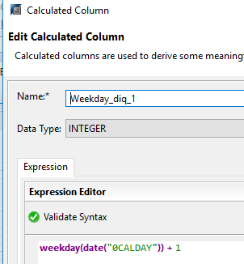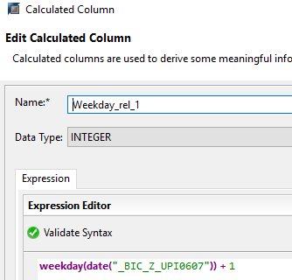
 | Source Field | Target Field
Weekday | 0CALDAY & Z_UPI0010 & Z_UPI0603 | Z_UPI0712

Weekday is calculated by based on calday get the weekday weekday_diq_1 & release day will be come out for weekday_rel_1 then as per the existing logic we have created below calculated column for weekday output. Based on the logic it will populate the data either ‘X’ or “ “(blank)
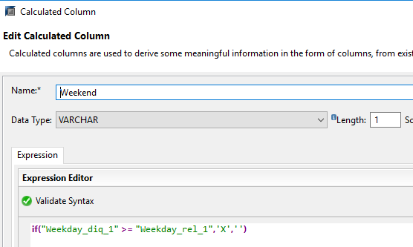

Read Table: Studio & Title(Midas) - /BIC/PZ_UPI0631 & /BIC/PZ_UPI0632 | Source Field | Target Field
MPM Title | Z_UPI0631 & Z_UPI0632 | Z_UPI0100

Read Table: Territory (Midas) - /BIC/PZ_UPI0626 | Source Filed | Target Field
Company code | 0COMP_CODE | 0COMP_CODE
Country | 0COUNTRY | 0COUNTRY
OpCo | Z_UPI0010 | Z_UPI0010

Finance Flow: This calculation view CV_INT_TBO_ZFSL has created on top of ZFEMP06. There is a logic written in the calculation view for the Heavy Currencies for the conversion on Z_UPI0026, Z_UPI0028 & Z_UPI00713.
Description | Source Filed | Target Field
Controlling area | 0CO_AREA | 0CO_AREA
Company code | 0COMP_CODE | 0COMP_CODE
Cost Center(SL) | 0COSTCENTER | 0COSTCENTER
Country key | 0COUNTRY | 0COUNTRY
Group Currency | 0CURKEY_GC | 0CURKEY_GC
Local Currency | 0CURKEY_LC | 0CURKEY_LC
Transaction Currency | 0CURKEY_TC | 0CURKEY_TC
Fiscal year/period | 0FISCPER | 0FISCPER
Posting Period | 0FISCPER3 | 0FISCPER3
Fiscal Year Variant | 0FISCVARNT | 0FISCVARNT
Fiscal year | 0FISCYEAR | 0FISCYEAR
Quantity | 0QUANTITY | 0QUANTITY
Unit of measure | 0UNIT | 0UNIT
Value type | 0VTYPE | 0VTYPE
OpCo | Z_UPI0010 | Z_UPI0010
Amount in Local Curr | Z_UPI0026 | Z_UPI0026
Amount in Group Curr | Z_UPI0027 | Z_UPI0027
Amount (OpCo) | Z_UPI0028 | Z_UPI0028
Op Co currency key | Z_UPI0035 | Z_UPI0035
MPM Title | Z_UPI0100 | Z_UPI0100
MPM Format Comp.View | Z_UPI0116 | Z_UPI0116
Account | Z_UPI0204 | Z_UPI0204
Format OpCo View UPI | Z_UPI0603 | Z_UPI0603
WBS Element | ZWBS_INTL | ZWBS_INTL
Transactional Curr | Z_UPI0713 | Z_UPI0713
MPM Format | Z_UPI0101 | Z_UPI0101
Owner – Royality | Z_UPI0103 | Z_UPI0103

Composite Provider:
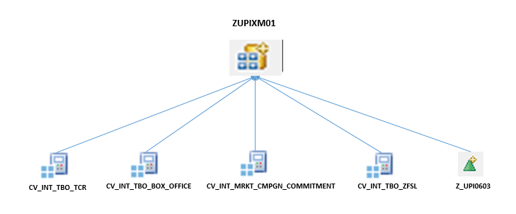

TCR mapping with Composite Provider: Below are direct mapping from source to target
Description | Source Filed | Target Field
Company code | 0COMP_CODE | 0COMP_CODE
Country key | 0COUNTRY | 0COUNTRY
Group Currency | 0CURKEY_GC | 0CURKEY_GC
Local Currency | 0CURKEY_LC | 0CURKEY_LC
Quantity | 0QUANTITY | 0QUANTITY
OpCo | Z_UPI0010 | Z_UPI0010
Amount in Local Curr | Z_UPI0026 | Z_UPI0026
Amount in Group Curr | Z_UPI0027 | Z_UPI0027
Amount (OpCo) | Z_UPI0028 | Z_UPI0028
Op Co currency key | Z_UPI0035 | Z_UPI0035
MPM Title | Z_UPI0100 | Z_UPI0100
Account | Z_UPI0204 | Z_UPI0204
Format OpCo View UPI | Z_UPI0603 | Z_UPI0603
Studio ID | Z_UPI0631 | Z_UPI0631
Title (Midas) | Z_UPI0632 | Z_UPI0632
Data Type | Z_UPI0640 | Z_UPI0640
Revision(TCR) | Z_UPI0641 | Z_UPI0641
Status (TCR) | Z_UPI0642 | Z_UPI0642
Planned Release Date | Z_UPI0643 | Z_UPI0643
Revision Status(TCR) | Z_UPI0644 | Z_UPI0644
Scrnd/Unscrd (TCR) | Z_UPI0647 | Z_UPI0647
Line Type (HO/Local) | Z_UPI0702 | Z_UPI0702

Box Office mapping with Composite Provider: Direct mapping from source to target

Description | Source Filed | Target Field
Calendar Day (Box) | 0CALDAY | 0CALDAY
Cal Year/Month(Box) | 0CALMONTH | 0CALMONTH
Calendar Year/Week | 0CALWEEK | 0CALWEEK
Calendar Year(Box) | 0CALYEAR | 0CALYEAR
Company code | 0COMP_CODE | 0COMP_CODE
Country key | 0COUNTRY | 0COUNTRY
Group Currency | 0CURKEY_GC | 0CURKEY_GC
Local Currency | 0CURKEY_LC | 0CURKEY_LC
Fiscal year/period | 0FISCPER | 0FISCPER
Posting Period | 0FISCPER3 | 0FISCPER3
Fiscal Year Variant | 0FISCVARNT | 0FISCVARNT
Fiscal year | 0FISCYEAR | 0FISCYEAR
OpCo | Z_UPI0010 | Z_UPI0010
Op Co currency key | Z_UPI0035 | Z_UPI0035
Counter(Box) | Z_UPI0062 | Z_UPI0062
MPM Title | Z_UPI0100 | Z_UPI0100
Account | Z_UPI0204 | Z_UPI0204
PlayWeek | Z_UPI0601 | Z_UPI0601
Territory (Midas) | Z_UPI0626 | Z_UPI0626
Studio ID | Z_UPI0631 | Z_UPI0631
Title (Midas) | Z_UPI0632 | Z_UPI0632
Box Office Type(Box) | Z_UPI0633 | Z_UPI0633
Weekend(Box) | Z_UPI0712 | Z_UPI0712

Finance mapping with composite provider: Below are direct mapping from source to target
Description | Source Filed | Target Field
Controlling area | 0CO_AREA | 0CO_AREA
Company code | 0COMP_CODE | 0COMP_CODE
Cost Center(SL) | 0COSTCENTER | 0COSTCENTER
Country key | 0COUNTRY | 0COUNTRY
Group Currency | 0CURKEY_GC | 0CURKEY_GC
Local Currency | 0CURKEY_LC | 0CURKEY_LC
Transaction Currency | 0CURKEY_TC | 0CURKEY_TC
Fiscal year/period | 0FISCPER | 0FISCPER
Posting Period | 0FISCPER3 | 0FISCPER3
Fiscal Year Variant | 0FISCVARNT | 0FISCVARNT
Fiscal year | 0FISCYEAR | 0FISCYEAR
Quantity | 0QUANTITY | 0QUANTITY
Unit of measure | 0UNIT | 0UNIT
Value type | 0VTYPE | 0VTYPE
OpCo | Z_UPI0010 | Z_UPI0010
Amount in Local Curr | Z_UPI0026 | Z_UPI0026
Amount in Group Curr | Z_UPI0027 | Z_UPI0027
Amount (OpCo) | Z_UPI0028 | Z_UPI0028
Op Co currency key | Z_UPI0035 | Z_UPI0035
MPM Title | Z_UPI0100 | Z_UPI0100
MPM Format Comp.View | Z_UPI0116 | Z_UPI0116
Account | Z_UPI0204 | Z_UPI0204
Format OpCo View UPI | Z_UPI0603 | Z_UPI0603
WBS Element | ZWBS_INTL | ZWBS_INTL

Marketing campaign to composite provider mapping: Below are direct mapping from source to target
Description | Source Filed | Target Field
Controlling area | 0CO_AREA | 0CO_AREA
Company code | 0COMP_CODE | 0COMP_CODE
Cost Center(SL) | 0COSTCENTER | 0COSTCENTER
Country key | 0COUNTRY | 0COUNTRY
Group Currency | 0CURKEY_GC | 0CURKEY_GC
Local Currency | 0CURKEY_LC | 0CURKEY_LC
Transaction Currency | 0CURKEY_TC | 0CURKEY_TC
Fiscal year/period | 0FISCPER | 0FISCPER
Posting Period | 0FISCPER3 | 0FISCPER3
Fiscal Year Variant | 0FISCVARNT | 0FISCVARNT
Fiscal year | 0FISCYEAR | 0FISCYEAR
Quantity | 0QUANTITY | 0QUANTITY
Unit of measure | 0UNIT | 0UNIT
Value type | 0VTYPE | 0VTYPE
OpCo | Z_UPI0010 | Z_UPI0010
Amount in Local Curr | Z_UPI0026 | Z_UPI0026
Amount in Group Curr | Z_UPI0027 | Z_UPI0027
Amount (OpCo) | Z_UPI0028 | Z_UPI0028
Op Co currency key | Z_UPI0035 | Z_UPI0035
MPM Title | Z_UPI0100 | Z_UPI0100
MPM Format Comp.View | Z_UPI0116 | Z_UPI0116
Account | Z_UPI0204 | Z_UPI0204
Format OpCo View UPI | Z_UPI0603 | Z_UPI0603
WBS Element | ZWBS_INTL | ZWBS_INTL

MPM Format OpCo View (UPI) to composite provider: Direct mapping from source to target
Description | Source Filed | Target Field
OpCo | Z_UPI0010 | Z_UPI0010
MPM Title | Z_UPI0100 | Z_UPI0100
Format OpCo View UPI | Z_UPI0603 | Z_UPI0603
Midas Release Date ( | Z_UPI0692 | Z_UPI0692

3.3.3 HANA Objects
In HANA studio below are the calculation views created for the Box Office Solution
TCR:
- CV_INT_TBO_TCR_RG
- CV_INT_TBO_TCR_REVISION
- CV_INT_TBO_TCR_COST_RG
- CV_INT_TBO_TCR_PCE
- CV_INT_TBO_TCR
Box Office Daily:
- CV_INT_TBO_BOX_DAILY
- CV_INT_TBO_BOX_CUMULATIVE
- CV_INT_TBO_BOX_POST
- CV_INT_TBO_BOX_OFFICE
Finance:
- CV_INT_TBO_ZFSL
Commitment:
- CV_INT_MRKT_CMPGN_COMMITMENT

3.3.4 Bex Queries

Query Technical Name | Description
X_MM_ZUPIXM01_009_YQ | MM-UPIXActualCommit_MKT_OpCo_UK
X_MM_ZUPIXM01_009_YQ_COPY | MM-UPIXActualCommit_MKT_OpCo_UK(Copy)
X_MM_ZUPIXM01_009_YQ_TEST | MM - UPIX Actual Commi_UK (Copy Test)
XXX_UPI_ACT_ECLIPSE | UPIActualQuery
Z_UPI_COST_CENTER_N | UPICostCenterQuery
Z_ZUPIXM0_LOCALDEAL | localdealbwtrial
Z_ZUPIXM01_0252 | UPITCRRollupbyOpcoUSD
Z_ZUPIXM01_0252_INITIAL | UPITCRInitialbyOpcoUSD
Z_ZUPIXM01_0252_V2 | UPITCRRollupbyOpcoUSD(MultipleTitle)
Z_ZUPIXM01_0262 | UPITCRRollupbyOpcoLC
Z_ZUPIXM01_0262_INITIAL | UPITCRInitialbyOpcoLocal
Z_ZUPIXM01_0262_V2 | UPITCRRollupbyOpcoLC(MultipleTitle)
Z_ZUPIXM01_0319 | UPIXP&LActuals-OpcoCurr&USD
Z_ZUPIXM01_050 | UPIXBOTCR
Z_ZUPIXM01_050_R | UPIXBOTCRReviseLatest
Z_ZUPIXM01_050_T | UPIXBOTCRReviseLatestTitleView
Z_ZUPIXM01_994 | UPIXDLMv3-OpcoCurr-OpcoList(withLE)
Z_ZUPIXM01_996 | UPIXDLMv3-OpcoCurr-OpcoList(noplan)
Z_ZUPIXM01_996_COPY | UPIXDLMv3-OpcoCurr-OpcoList(noplan)
Z_ZUPIXM01_999 | UPIXOriginalTCRSubmissions

4.0 Assumptions & Dependencies

4.1 Assumptions
- Export data source to be create for loading historical Master and transitional data from existing System for acquisition layer

4.2 Dependencies
None

5.0 Reference Documents
BW Intl - Design Workshop:
https://teams.microsoft.com/_?tenantId=bdef8a20-aaac-4f80-b3a0-d9a32f99fd33#/files/unknown?groupId=0bb444c9-5597-47ce-b1cd-093a594e571d&threadId=19:06eb554a86d4461690808cec89369980@thread.skype&ctx=channel&context=Project%2520Tracker

6.0 Open Items
Sr. No. | Description | Current Status | Current Owner
1

